|  |  |  |  |
| --- | --- | --- | --- |
| **Grade** | **100 % Scale** | **Scale GPA** | **Definition** |
| A  A- | 93-100  90-92 | 4.0  3.7 | Designates the status of a student who consistently demonstrates a thorough understanding and skill application in the content area and curriculum objectives for the grade/course level. |
| B+  B  B | 87-89  83-86  80-82 | 3.3  3.0  2.7 | Designates the status of a student who demonstrates a high degree of understanding and skill application in the content area and curriculum objectives for the grade/course level. |
| C+  C  C | 77-79  73-76  70-72 | 2.3  2.0  1.7 | Designates the status of a student who demonstrates a satisfactory understanding and skill application in the content area and curriculum objectives for the grade/course level. |
| D+  D | 67-69  64-66 | 1.3  1.0 | Designates the status of a student who needs significant practice and instructional experiences to acquire the knowledge of basic content and skills specified in the content area and curriculum objectives for the grade/course level. |
| F | 63 and  below | 0.0 | Designates the status of a student who has not demonstrated the basic knowledge of content and/or skills specified and requires additional practice and instructional experiences in order to succeed curriculum objectives for the grade/course level. |

|  |
| --- |
|  |

B+

B

B87-89

83-86

80-82

3.3

3.0

2.7

Designates the status of a student who demonstrates a high

degree of understanding and skill application in the content

area (e.g., SOL and curriculum objectives for the grade/course

level).

C+

C

C77-79

73-76

70-72

2.3

2.0

1.7

Designates the status of a student who demonstrates a

satisfactory understanding and skill application in thecontent

area (e.g., SOL and curriculum objectives for the grade/course

level).

D+

D

67-69

64-66

1.3

1.0

Designates the status of a student who needssignificant

practice and instructional experiences to acquire the

knowledge of basic content and skills specified in the content

area (e.g., SOL and curriculum objectives for the grade/course

level).

E 63 and

below

0.0 Designates the status of a student who has not demonstrated

the basic knowledge of content and/or skills specified and

requires additional practice and instructional experiencesin

order to succeed (e.g., SOL and curriculum objectives forthe

grade/course level)Mooncakes

Erntedankfest is a holiday that is equivalent to Thanksgiving. Translated to “harvest thanksgiving festival,” it is celebrated by religious and rural groups. In the rural community observances with churches, a country fair and a parade are tradition. In larger cities the Catholic and Protestant church sponsors, Erntedankfest and observances begin with choral singing and a sermon complete with the presentation of the Erntekrone, the “harvest crown.” Evening services consist of a torch parade and fireworks.

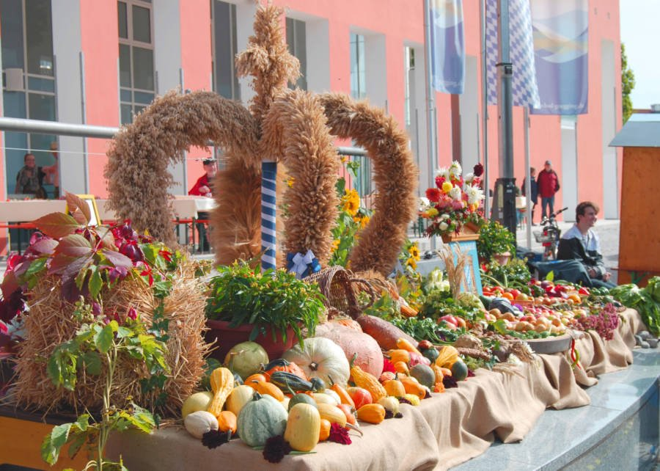

Norfolk- The inspiration of Thanksgiving on Norfolk Island comes from America except that Norfolk Island celebrates on the last Wednesday rather than on a Thursday. On Thanksgiving it is customary that the pews of the All Saints Church are decorated with stalks of corn. During church services, attendees place fresh fruit and vegetables along the isle. This is considered to be a testament of agricultural self-sufficiency. After the service the produce is loaded onto the table and sold to raise funds. The Norfolk Island Food Festival takes place on Thanksgiving annually including the holiday unique feast.

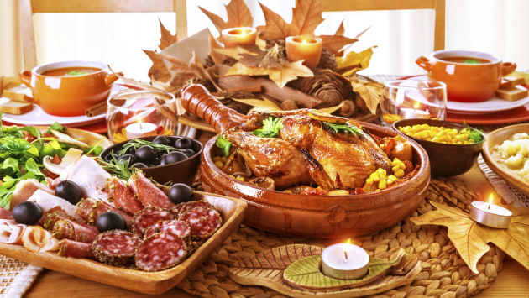

Norfolk Island Thanksgiving dinner

Known as Chuseok, it is one of the biggest holidays in Korea. It is sometimes referred to as “Korean Thanksgiving” because it’s a special time for family, food, friends, also to friends and business acquaintances to show their thanks and appreciation. Chuseok occurs on the 15th day of the 8th month of the lunar calendar (usually around late September to early October) on the full moon and lasts 3 days. It isn’t necessary to give gifts during Chuseok, but it is a polite gesture. Such gifts include olive oil, tuna sets, spam sets and coffee sets.

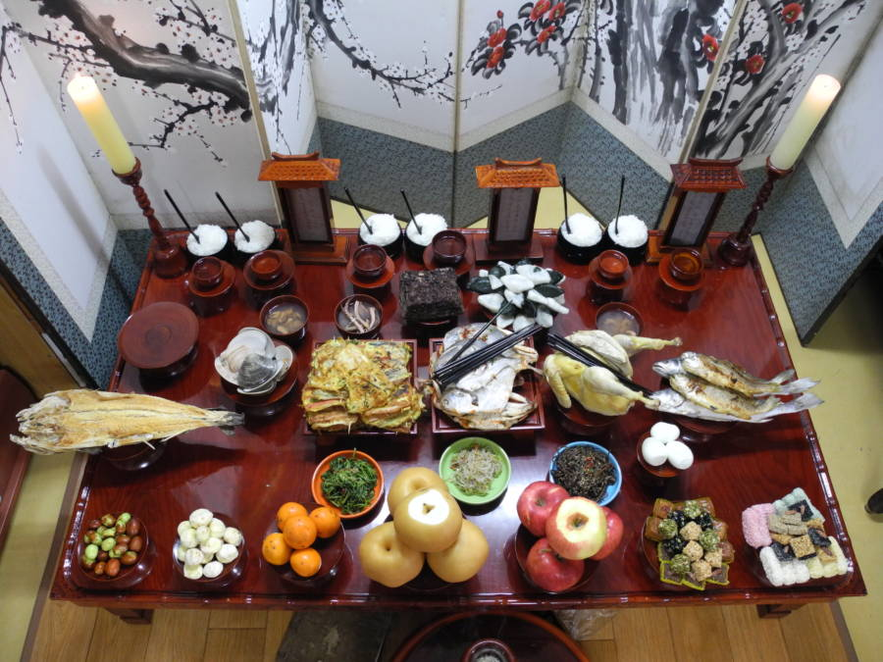

Chuseok feast

**Food of thanksgiving**

When we discuss the topic of Thanksgiving we have to set aside some time to think about the feasts and how certain foods became a customary practice in the United States. Thanksgiving is the oldest holiday in America, the food that colonists and Native Americans might have eaten so many years ago were different with that of today. This lesson will look explore the history behind certain dishes that are placed at the dinner table during Thanksgiving.

Pumpkin pie can be traced back to the 1600s, when European settlers first discovered pumpkins and brought them back to England. Hollowing out a pumpkin, filling it with spices and sweetened milk and coking it directly over a fire was the common method to make pumpkin pie. By the 18th century the pumpkin pie became popular as well a common dessert served on Thanksgiving.

Stuffing or dressing is commonly served on Thanksgiving either inside or outside of the turkey. No evidence shows that Pilgrims actually served this on Thanksgiving instead some sort of wild game served with wild rice is evident. Throughout the years Bostonians and New Englanders used cornbread as a base and added chestnuts thus contributing to the basis of creating stuffing.

It is quite difficult to prove that Native Americans ate cranberries for Thanksgiving although the fruit was regularly consumed. Cranberry sauce recipes date back to the 1700s in a cook book written by Amelia Simmons. Canned cranberry sauce was invented by Marcus Urann a former lawyer who ran a cranberry bog.

Pasta and cheese were popular within European regions hundreds of years ago. In 1769 Elizabeth Raffald included a recipe that mixed cheddar sauce with cheese over a noddle casserole served with parmesan and breadcrumbs. This dish is known today as macaroni and cheese. Some say that the dish was brought to America by European settlers while other speculate that Thomas Jefferson brought it back to America after a trip in Europe.

The popular Thanksgiving Day turkey was not served at the dinner table during colonial times. Instead pilgrims and Native Americans ate fowl or goose. The thought of eating turkey for Thanksgiving can be attributed to their large size to feed a lot of people and accessibility in earlier days. It was not until the mid-19th century that the turkey became a staple of the holiday. Baker (2009, p. 32) tell us that the turkey was not only the showpiece of the dinner but also the primary icon of the holiday itself. At this time student can log into Seesaw and complete the Thanksgiving feast worksheet.